MEASURING THE PULSE OF PROSPERITY: AN INDEX OF ECONOMIC FREEDOM ANALYSIS

**1. INTRODUCTION**

**1.1 Overview**

One of the main factors in attracting investments is directly linked to the climate of economic freedom. Attaining economic freedom and non-intervention of government is vital in this regard.

For twenty-nine years the index has delivered thoughtful analysis in a clear, friendly, and straight-forward format. With new resources for users and a website tailored for research and education, the index of economic freedom is poised to help readers track over two decades of the advancement in economic freedom, prosperity, and opportunity and promote these ideas in their homes, schools, and communities.

Economic freedom is the fundamental right of every human to control his or her own labor and property. In an economically free society, individuals are free to work, produce, consume, and invest in any way they please. In economically free societies, governments allow labor, capital, and goals to move freely, and refrain from coercion or constraint of liberty beyond the extent necessary to protect and main liberty itself.

We measure economic freedom based on 12 quantitative and qualitative factors, grouped into four broad categories, or pillars, of economic freedom.

1. Rule of law (property rights, government integrity, judicial effectiveness)

2. Government Size (government spending, tax burden, fiscal health)

3. Regulatory Efficiency (business freedom, labor freedom, monetory freedom)

4. Open Markets (trade freedom, investment freedom, financial freedom)

Each of the twelve economic freedoms within these categories is graded on a scale of 0 to 100. A country’s overall score is derived by averaging these twelve economic freedoms, with equal weight being given to each. More information on the grading and methodology can be found in the appendix.

**1.2 Purpose**

The purpose of this project is to analyzing the relationships and impacts of the 12 factors of economic freedom among the countries of the world. Help of the data set of index of economic freedom we make such analysis by using tableau software. Using tableau, we make dashboard and story for data visualization. The objective of index of economic freedom is to Promoting Economic Opportunity, Individual Empowerment & Prosperity.

**2. PROBLEM DEFINING AND DESIGN THINKING**

**2.1 Empathy map**

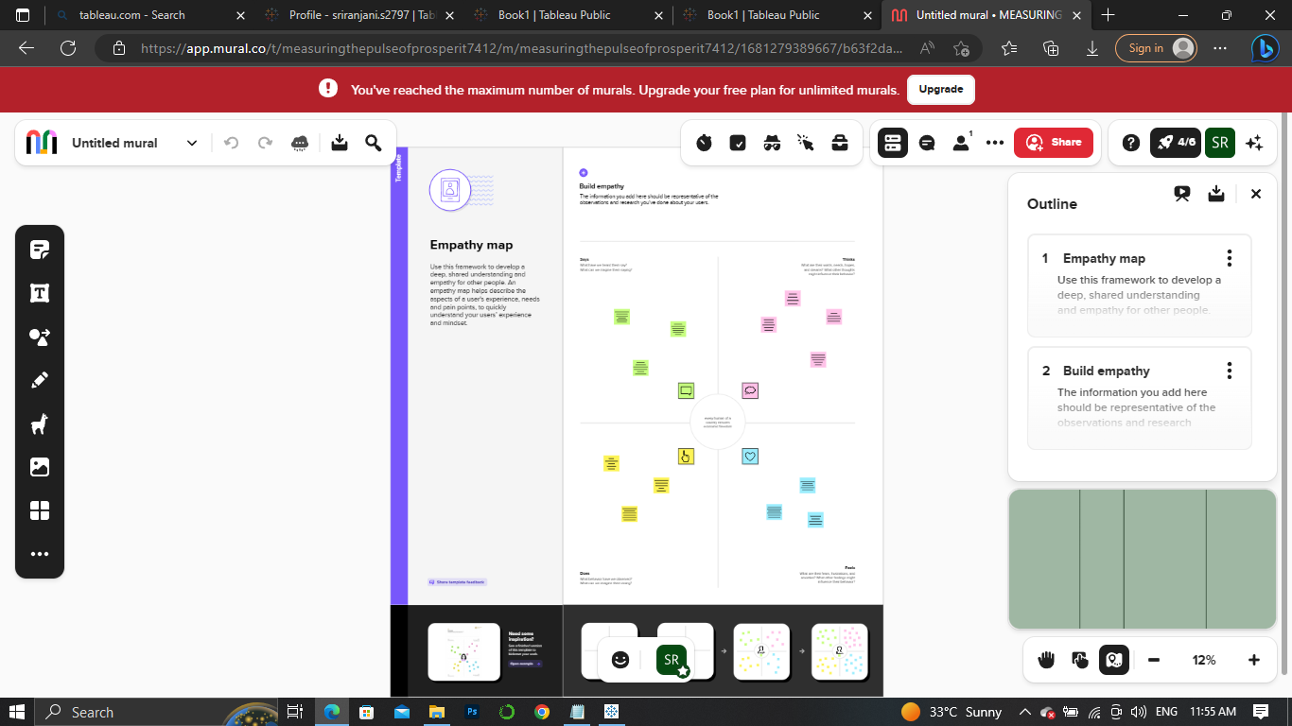

**2.2 Ideation & Brainstorming Map**

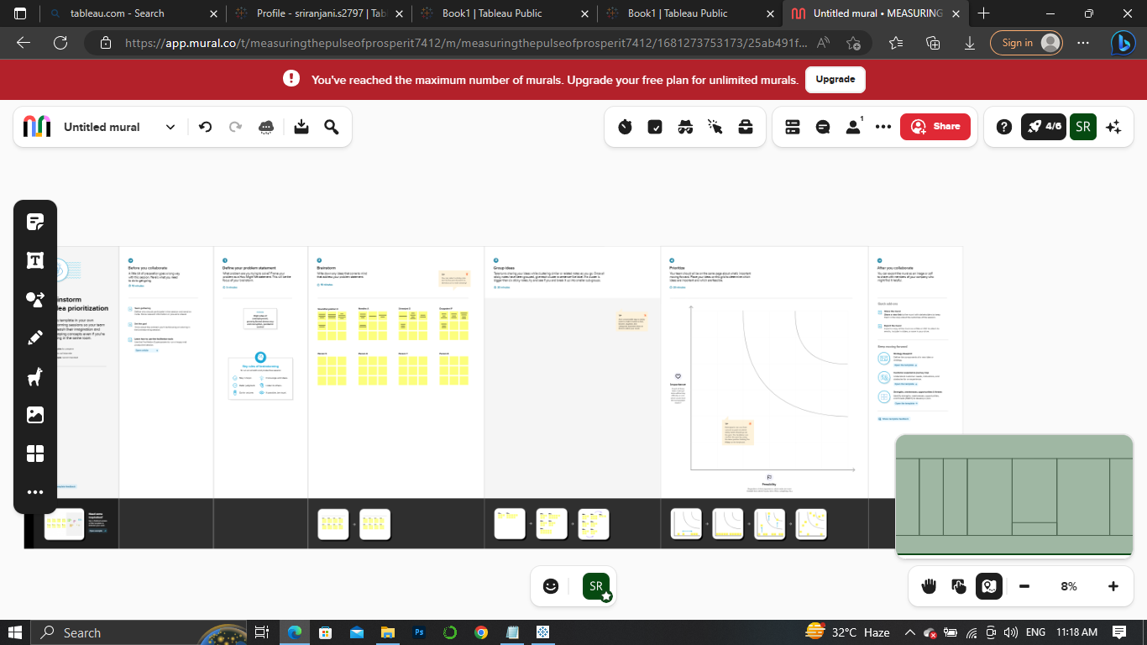

**3. RESULT**

**Data set:**

[index_of_economic_freedom.csv - Google Drive](https://drive.google.com/file/d/1EBIa1LtM3Ni2Uh3nekLB6wt3263Q3NeX/view)

**1) 2022 Economic freedom score**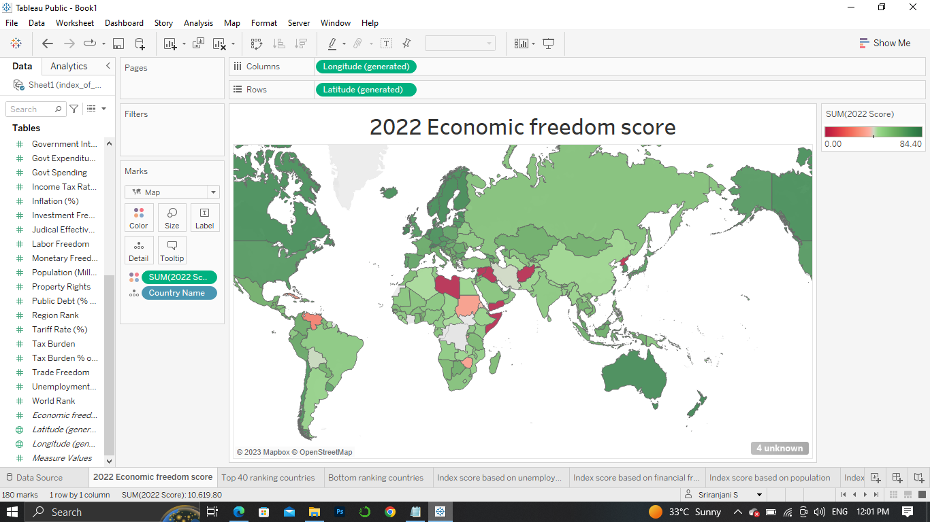

**2) Top 40 ranking countries in the index**

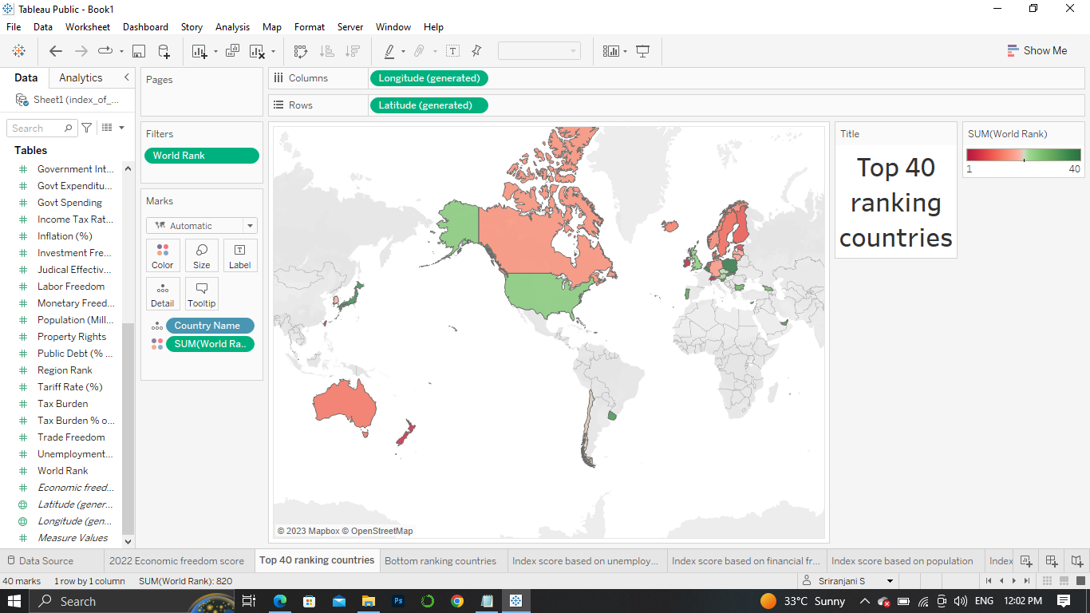

**3) Bottom ranking countries**

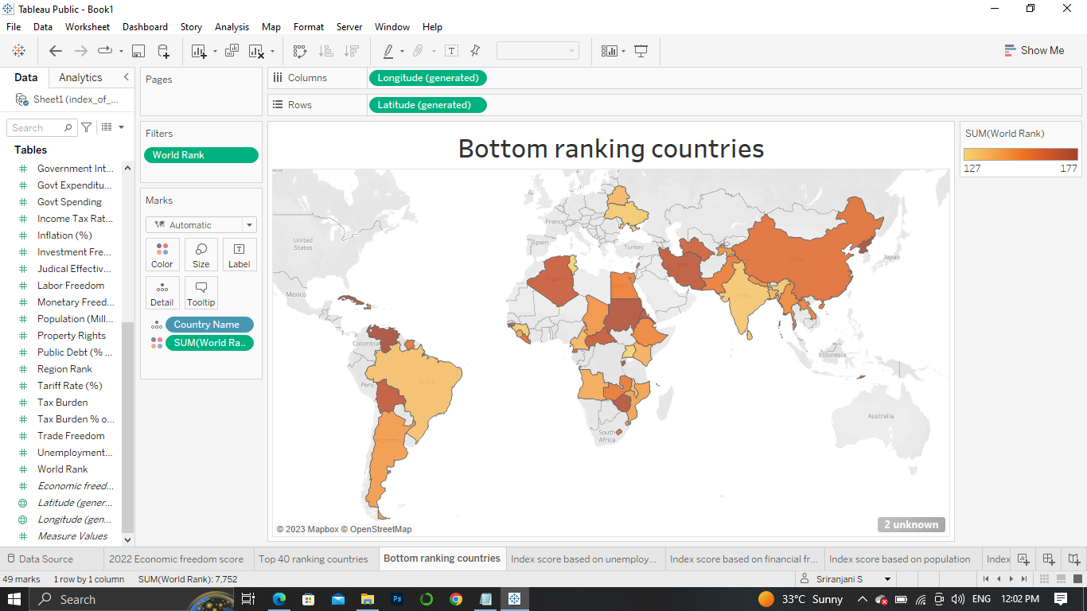

**4) Index score based on unemployment rate**

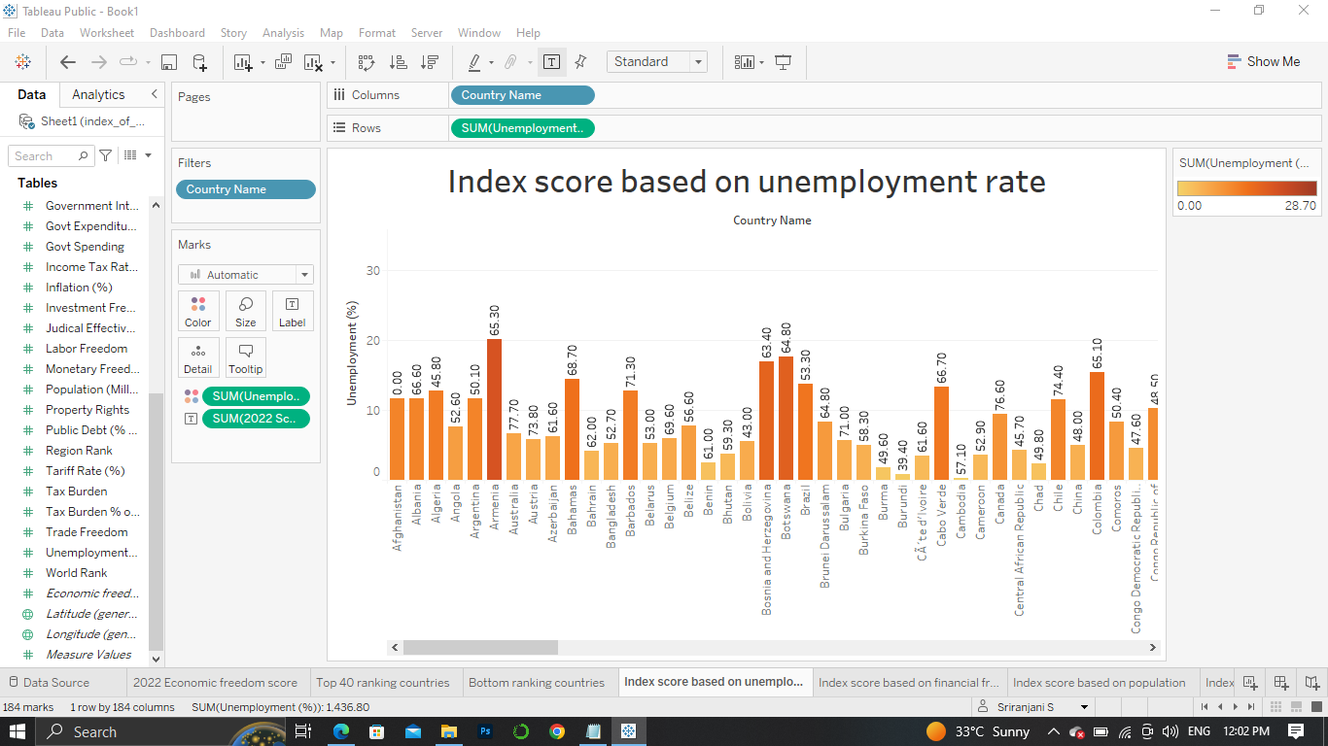

**5) Index score based on financial freedom**

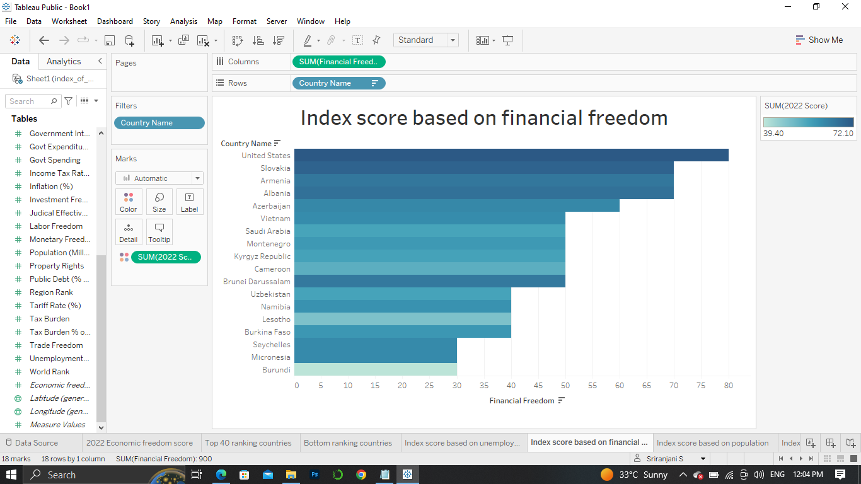

**6) Index score based on population**

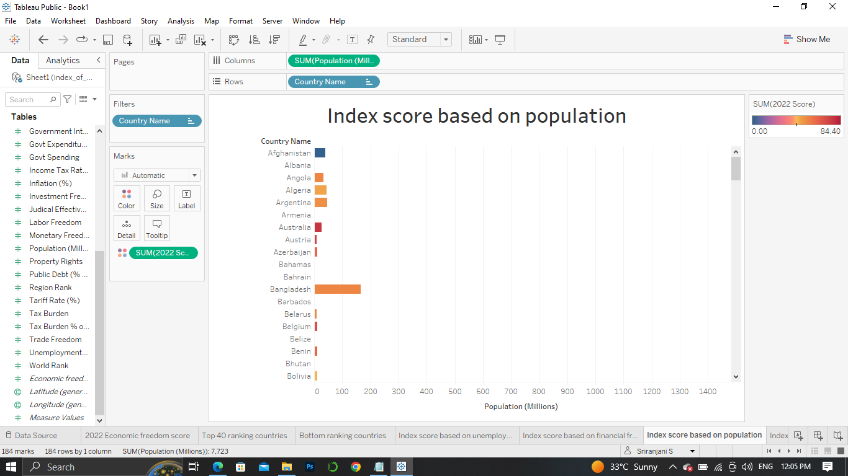

**7) Index score based on 5 year GDP growth rate**

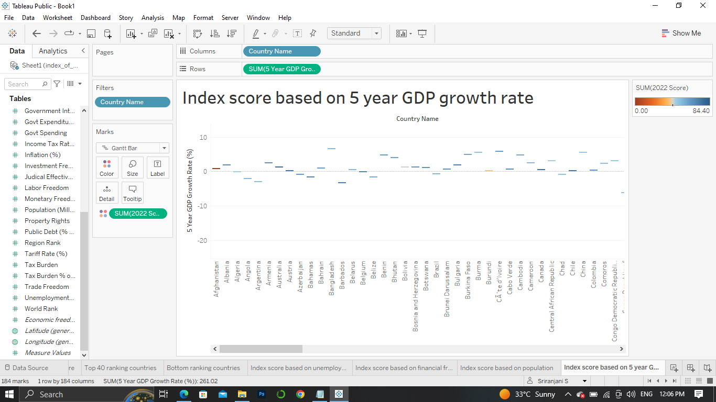

**8) Inflation rate in different countries**

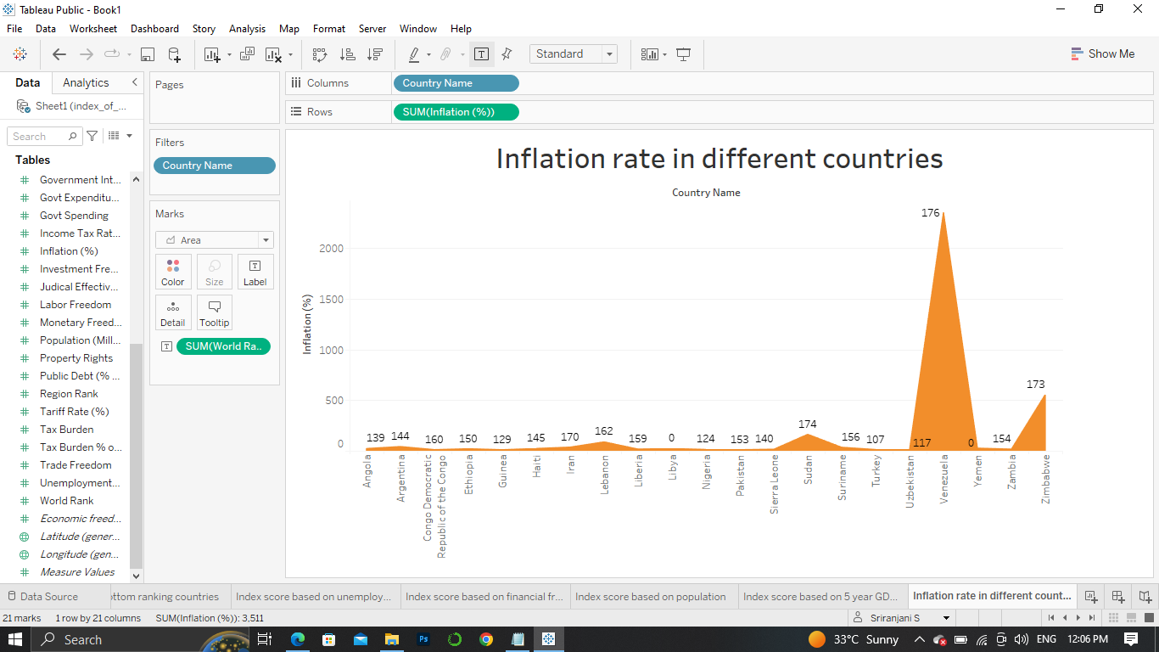

**9) Correlation between inflation and unemployment**

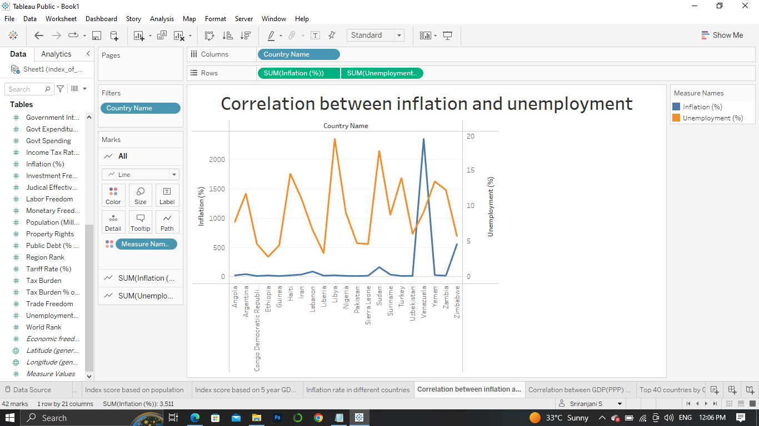

**10) Correlation between GDP(PPP) and monetory freedom**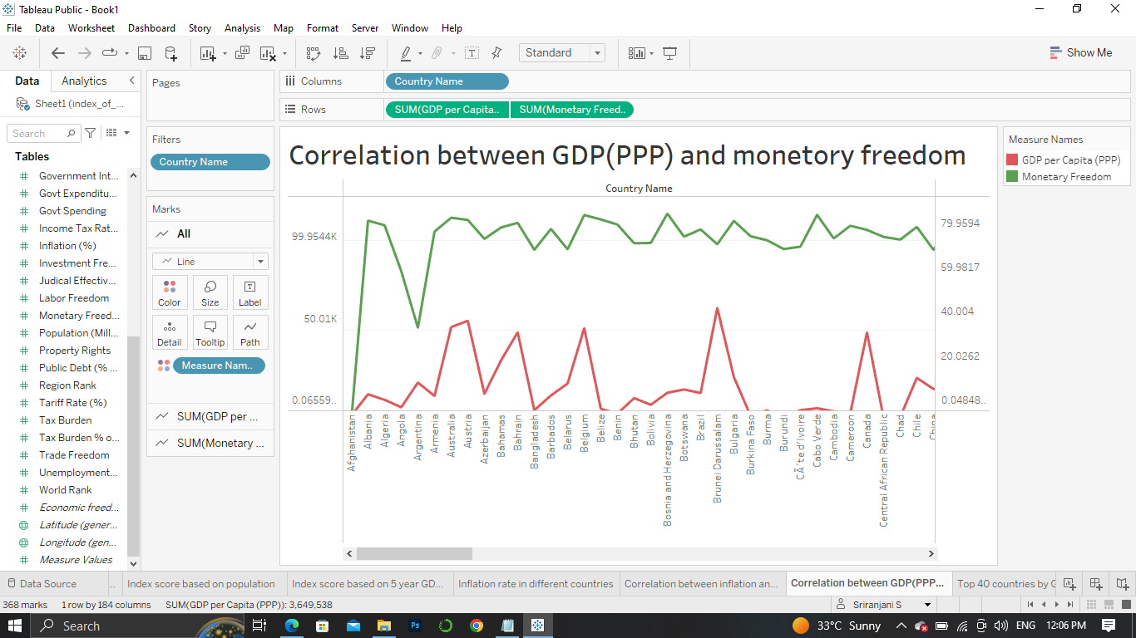

**11) Top 40 countries by GDP growth rate**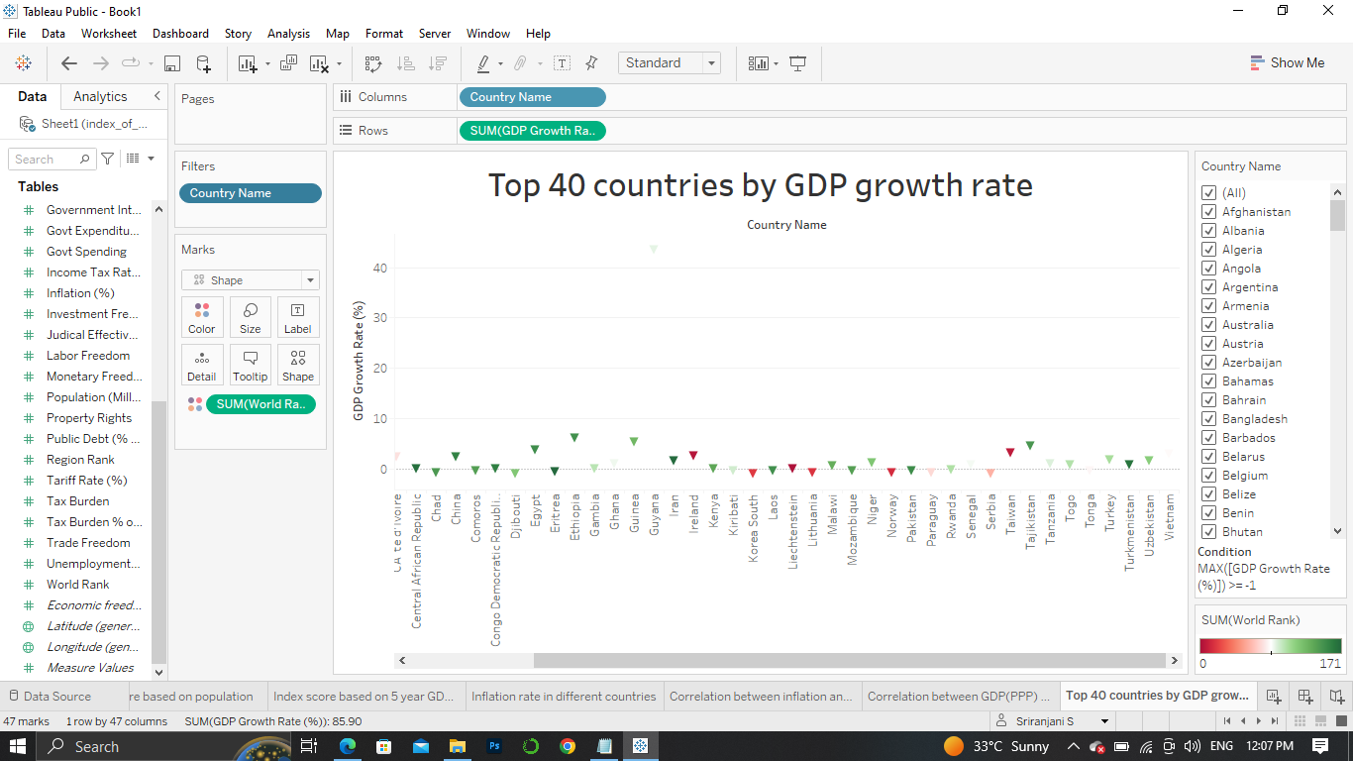

**DASHBOARD**

[Book 1(dashboard 1) | Tableau Public](https://public.tableau.com/app/profile/sriranjani.s2797/viz/Book1dashboard1_16812820065670/Dashboard1)

[Book 1(dashboard 2) | Tableau Public](https://public.tableau.com/app/profile/sriranjani.s2797/viz/Book1dashboard2_16812823621440/Dashboard2)

**STORY**

[Book 1(story 1) | Tableau Public](https://public.tableau.com/app/profile/sriranjani.s2797/viz/Book1story1_16812826659730/Story1)

**WEB APPILCATION FILES**

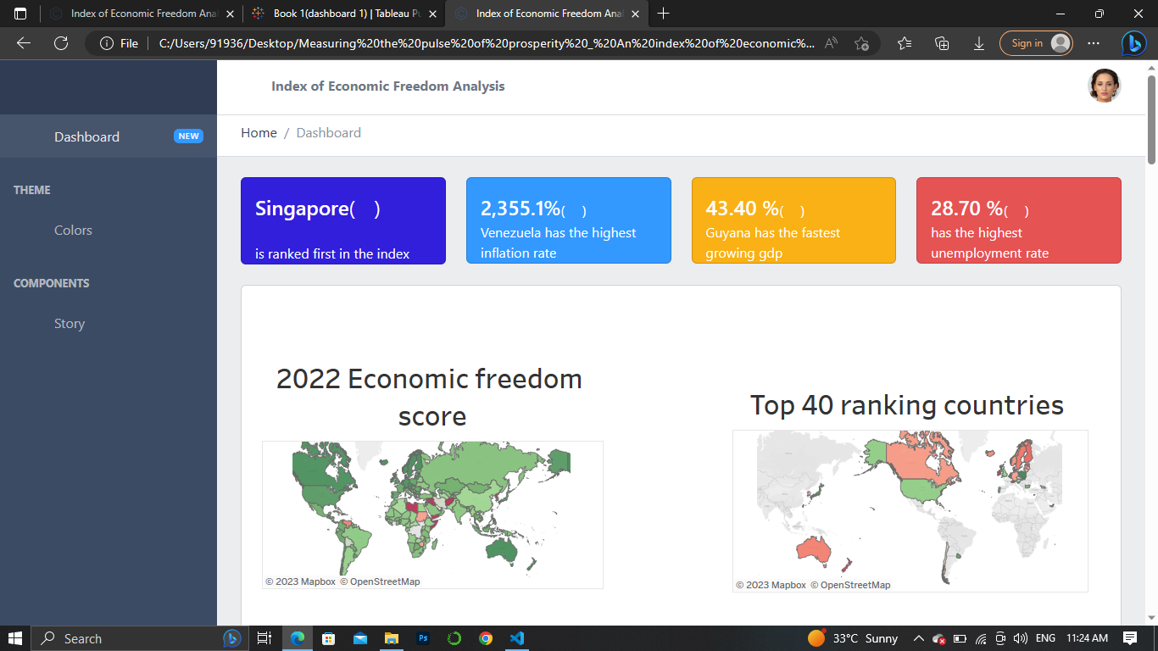

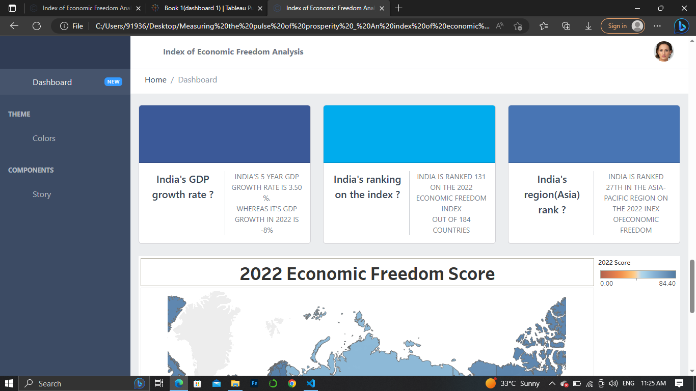

**4. ADVANTAGES & DISADVANTAGES**

**ADVANTAGES**

* The Index of Economic Freedom is a helpful tool for a variety of audiences, including academics, policymakers, journalists, students, teachers, and those in business and finance. The Index is an excellent objective tool for analyzing 184 economies throughout the world and each country page is a resource for in-depth analysis of a country’s political and economic developments. The 12 economic freedoms and accompanying historical data also provide a comprehensive set of principles and facts for those who wish to understand the fundamentals of economic growth and prosperity.
* Economic freedom brings greater prosperity. The Index of Economic Freedom documents the positive relationship between economic freedom and a variety of positive social and economic goals. The ideals of economic freedom are strongly associated with healthier societies, cleaner environments, greater per capita wealth, human development, democracy, and poverty elimination.

**DISADVANTAGES**

* Seamless liberty may causes the economic crises. Economic freedom affect by political freedom, wealth and democracy level.
* It is critical to explore which features of the economic freedom indices are noteworthy for growth and the pathway of these effects.

**5. APPLICATIONS**

* An index of economic freedom is a composite measure of the quality of political-economic institutions across different jurisdictions.
* Scores and ranks in an index are based on criteria that the creators of the index judge as being relevant, which vary from one index to another.
* These indexes are motivated by the observation that economies that are more free-market based tend to experience greater levels of investment, more rapid growth, and higher average incomes.
* Investors can use the index of economic freedom as a quick way to monitor the changes in economies where they are interested in exposure.
* Heritage Foundation publishes the most widely-used economic freedom index. However, several institutions publish their own indices

**6. CONCLUSION**

An economic freedom index allows researchers to examine the empirical relationships between economic freedom and other desirable social outcomes. The big question is: Do countries that exhibit greater degrees of economic freedom perform better than those that do not?

Much scholarly research has been and continues to be done to see if the index correlates with various measures of the economic freedom: inflation rate, GDP growth rate, unemployment rate, and so on.

**7. FUTURE SCOPE**

The scope of economic freedom is economically free society

Economic freedom is commonly accounted to show as a good reason for growth and distribution of income in most econometric analysis. However, economic freedom may also be affected by political freedom, wealth, or democracy level, Economic freedom refers to providing protection of property rights and enforcement of contracts, freedom of individual choice and voluntary exchange with limited government scale.

**8. APPENDIX**

<https://www.econlib.org/library/Enc/EconomicFreedom.html>

<https://www.heritage.org/index/about>